EXPERIMENT IV BASIC APPLICATIONS OF OPERATIONAL AMPLIFIERS



Fall - 2023/2024
EEE 281 – Electrical Circuits Lab 4 Report

Submitted by: Yağmur Can 263753| Eda İslam 2585081
DATE:

Objective:
In this experiment we will study the basic applications of operational amplifiers.
- We will learn how to control transfer characteristics of circuits using different resistor configurations.
- We will learn how to apply node analysis to op-amp circuits.
- We will learn to use feedback techniques to deliver op-amp circuits.
- We will observe the fundamental specifications and limitations of practical op-amps.
- We will use a function generator and oscilloscope during our experiments.
Equipment & Component List:
DC Power Supply
Function/Arbitrary Waveform Generator
Digital Oscilloscope Op-Amp (μA741)
Resistors (2x100 Ω, 4 x 1kΩ)
Results:
- Open-loop operation (without feedback)

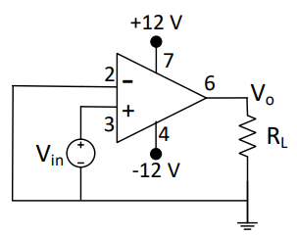

We created the above circuit in the lab environment by making the essential connections. And measure the value of output voltage (Vo) by applying the values of Vin and RL.

Vin(V) | RL(Ω) | Vo(V) | Input current, i+(mA) | Is output voltage saturated? (Yes/No) | Is output voltage limited by op-amp output current limit? (Yes/No)
0.002 | 3000 | 11.06 | 1 | Yes | Yes
0.002 | 200 | 4.32 | 1 | Yes | Yes
2 | 200 | 4.20 | 1 | Yes | Yes
Table 1

While measuring the values of Vo by the given Vin values we skipped the Vin= 10 μV value since the value is too low for the equipment.

Comparing the measured values of the output voltage from Table 1 and the calculated values from the pre-work, we see that the values are nearly same with each other. The discrepancies between the values can be caused by the temperature variations, material aging and the resistance of the cables in the experiment part.

- Voltage follower (buffer) characterization
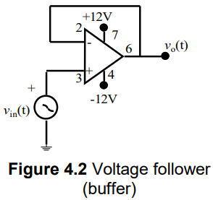

We created the above circuit with the given value of Vin(t)=3sin1000πt. Setting the function generator in HZ mode, implying the values of frequency as 500 Hz and the amplitude as 6 Vpp in function generator our circuit is completed.

A)

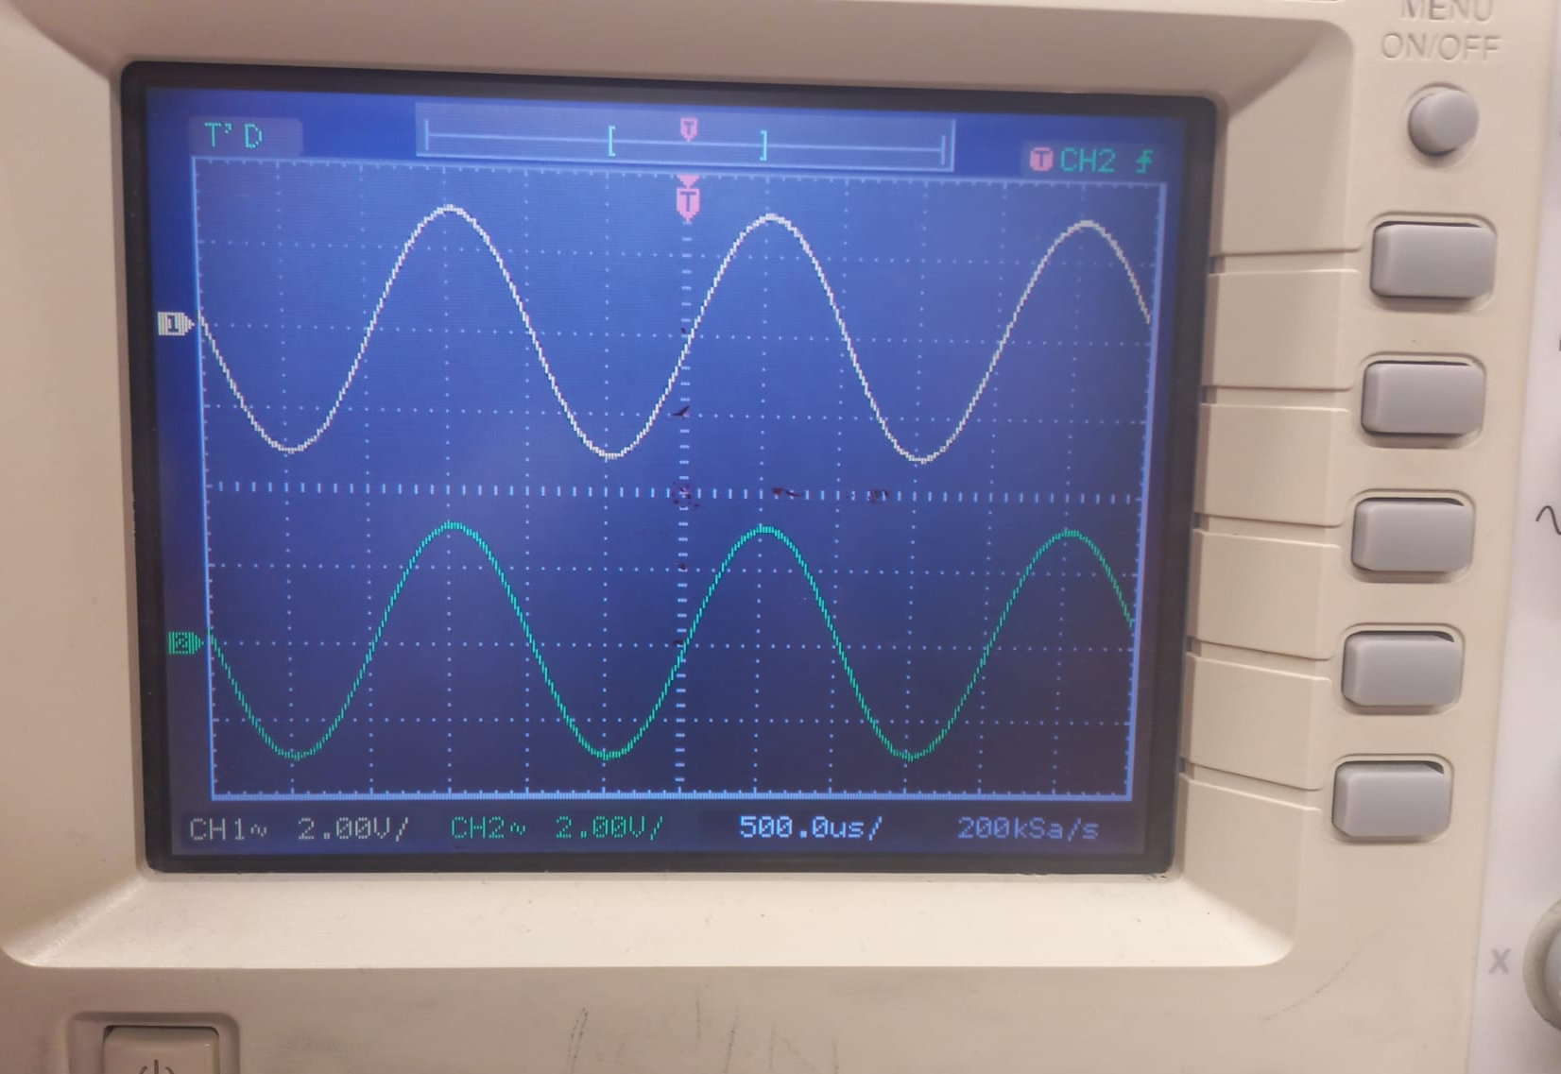

Figure 1: Non saturated

In figure 1, arranging the amplitude as 6 Vpp and connecting channel 2 to the output voltage, we don’t observe saturation effects on the oscilloscope.
We increased the amplitude until the output saturates and observed that the maximum amplitude of Vin(t) is 20 Vpp.
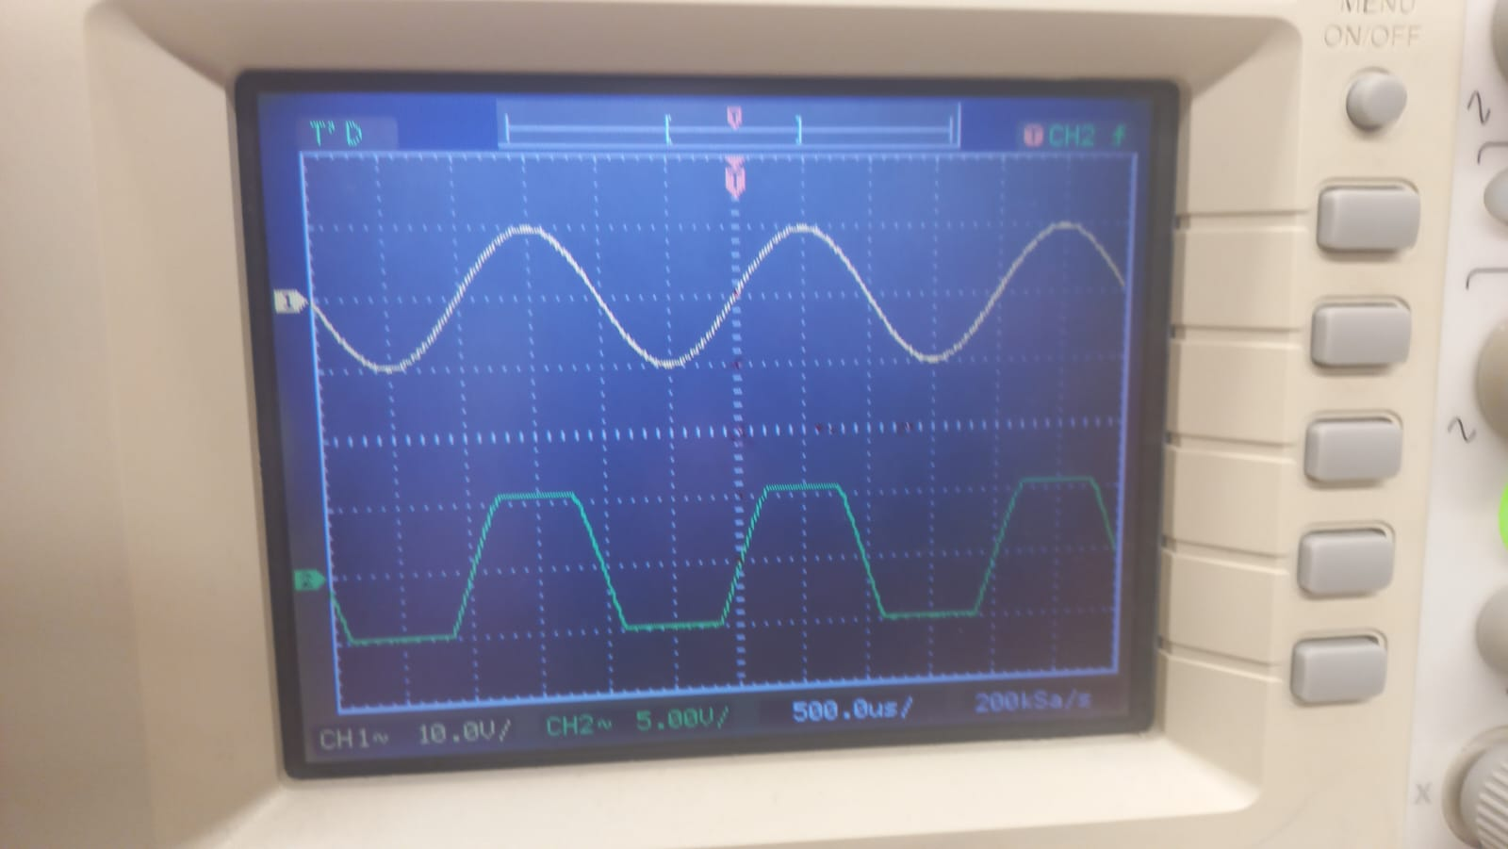

Figure 2: Saturated

In figure 2, arranging the amplitude as 20 Vpp, we observe the graph of the output voltage in the oscilloscope. We observe that this value is accurate with the value in the op-amp data sheet which is 20 V/mV.
B)
We obtain the graph of Vo versus Vin using the oscilloscope by connecting channel 1 to the Vin and connecting channel 2 to Vo.
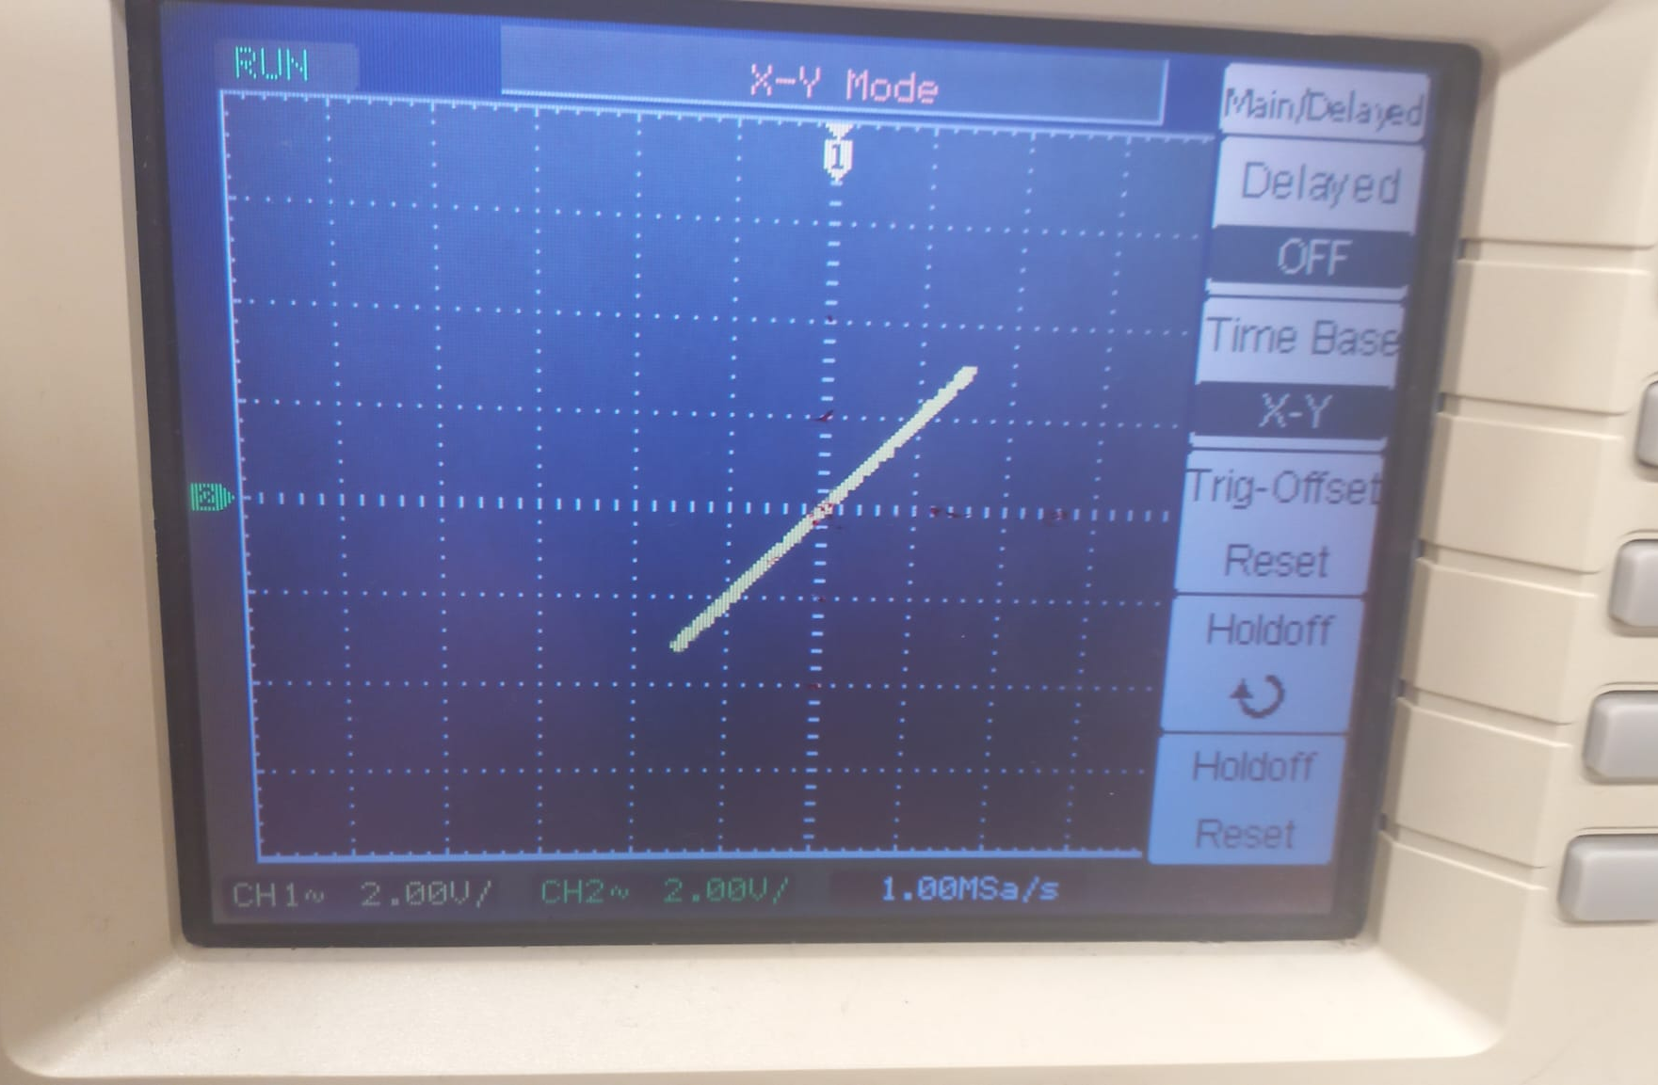

Figure 3: Non saturated
In figure 3, we can observe that Vo has a linearly increasing graph between -Vcc and +Vcc until the amplitude is 20 Vpp.

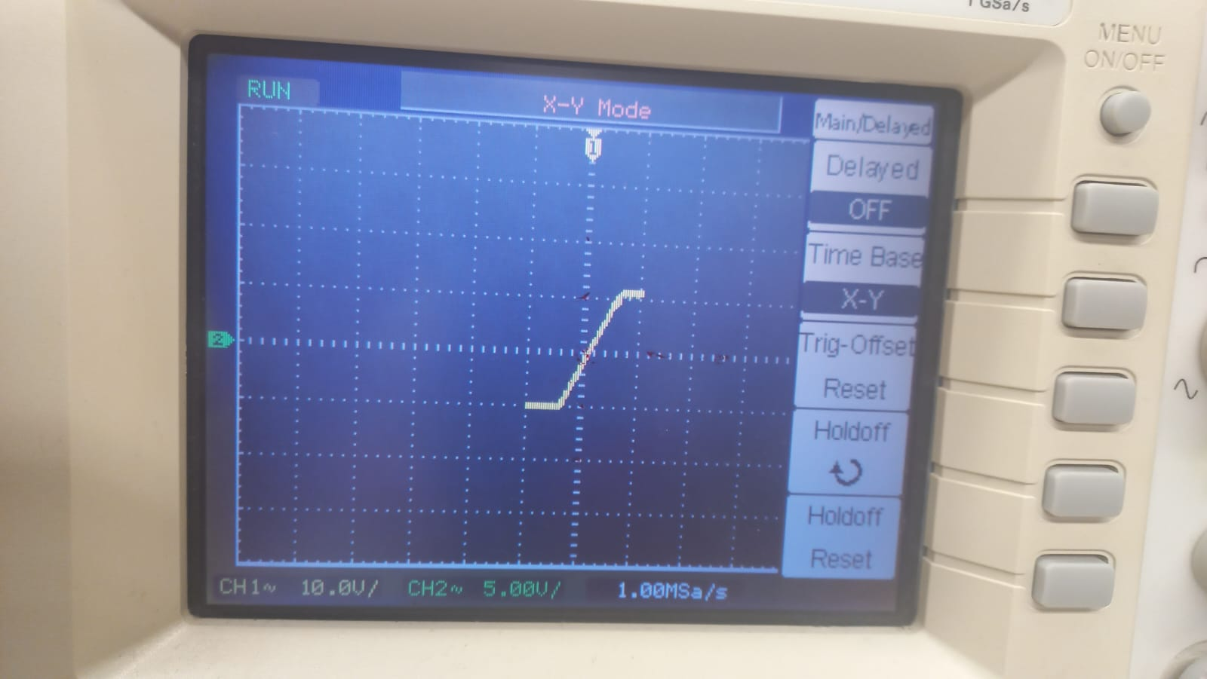

Figure 4: Saturated

In figure 4, we can observe that Vo is saturated when the amplitude is greater and equal to 20 Vpp. Vo is saturated if it is less than -Vcc and greater than +Vcc. We viewed the graph as fixed when these conditions are provided.

3) Summer and Subtractor (Difference) Circuits
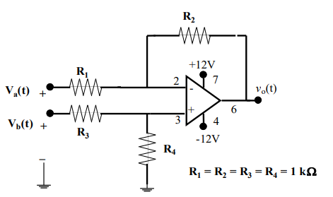

We created the above circuit with the given values Va(t)= 2sin1000πt V, Vb(t)= 2V and R1=R2=R3=R4=1kΩ.
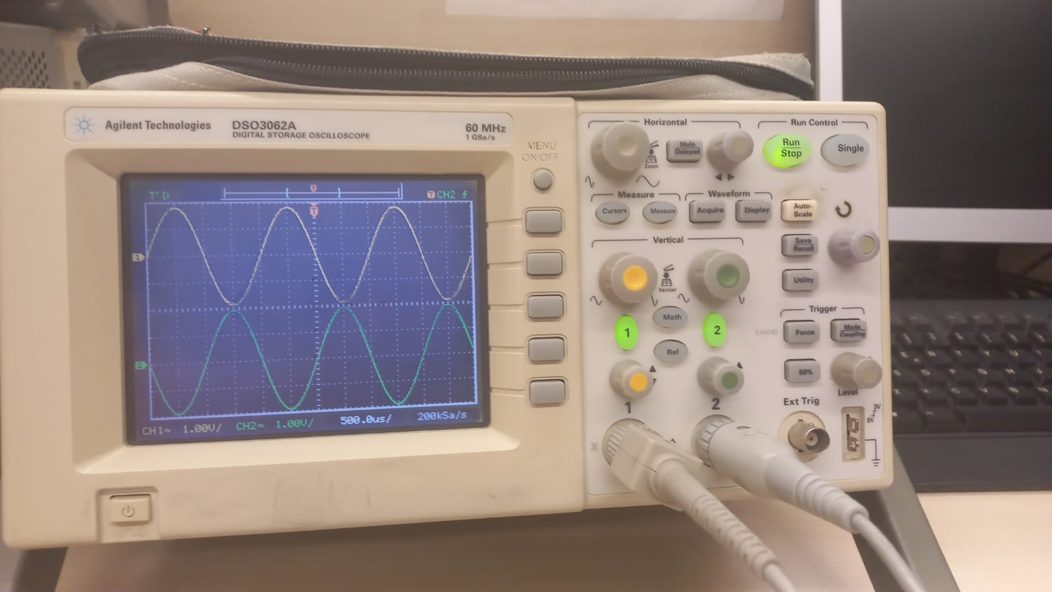

Figure 5

In figure 5, we observed the signals by connecting channel 1 to the Va(t) and connecting channel 2 to Vo(t). We saw that the calculations and the simulated signals are the same as our experimental set up values.
Unfortunately, we didn’t reduce the Vb(t) slowly and observe what happens and we couldn’t set up the summer circuit due to the time limit of the lab hours.
Conclusion:

